# Implemetation

## Database

Database connection

First thing we have to do is to open Oracle SQL developer and create new connection. We will name it connection-workingHours, user name is sys and password is the one that you declared once SQL was installed on your computer, optionally you can save your password. Connection type is basic by default and you have to choose SYSDBA as a role in order to be able to have all system roles. We are connected via local host on port 1521 and SID is ‘xe’ by default. After that you can click on test connection to verify if everything is set in place and finally you can click on CONNECT button.

Creating database user(admin)

Once we are connected need to create a new user. In connection menu find a folder 'Other users' and right click on that folder and select option Create User.

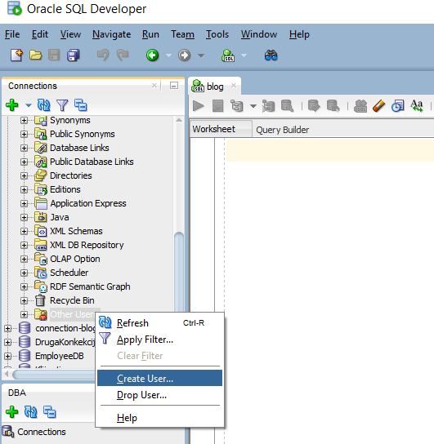

After this we need to set up username, password and to choose SYSTEM as default Tablespace and TEMP as Temporary Tablespace.

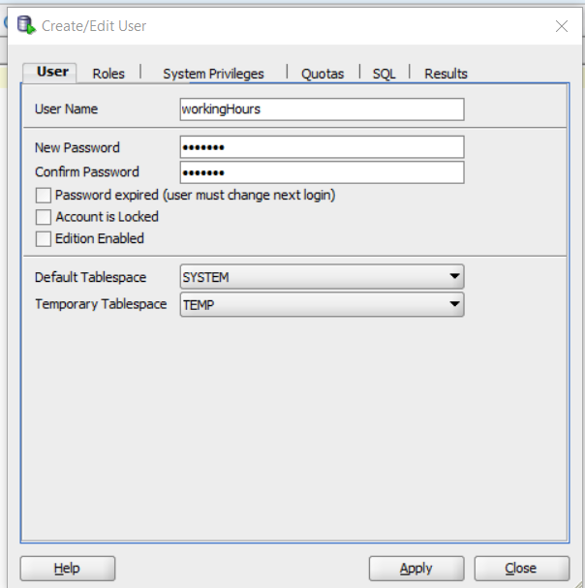

Next step is to click on option Granted Roles and choose Grant All.

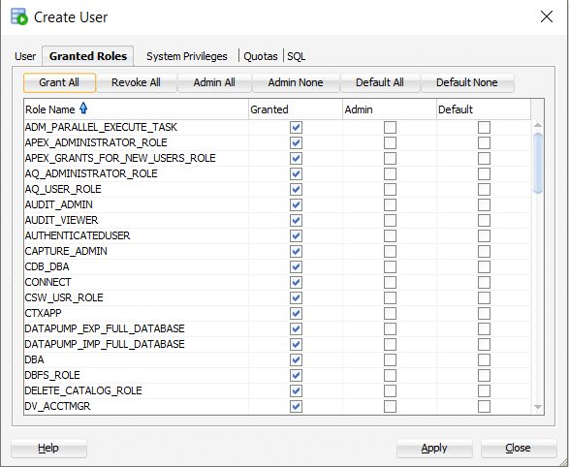

After that you need to click on System Privileges and choose option Grant All. Once you have done with setting all parameters you can click on Apply button in bottom right corner of this window and you have successfully created a new user.

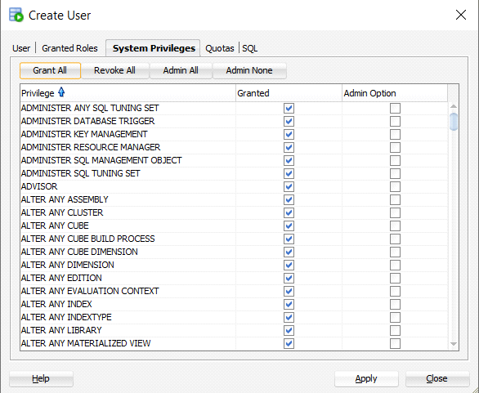

Our next step is to connect as a new user. Choose username and password that you defined in previous steps and click OK to connect.

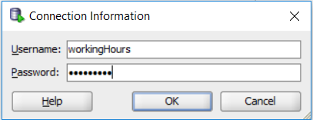

Find our file in project which is called bazaFinal.txt select all from that file and paste it into SQL developer and then click on run script button which is on top left corner.

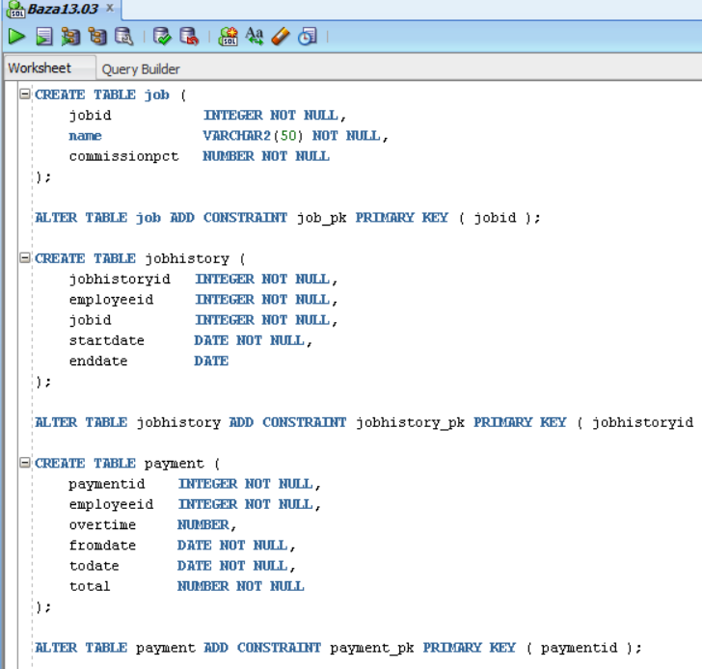

## Backend implementation

Clone or download project from git

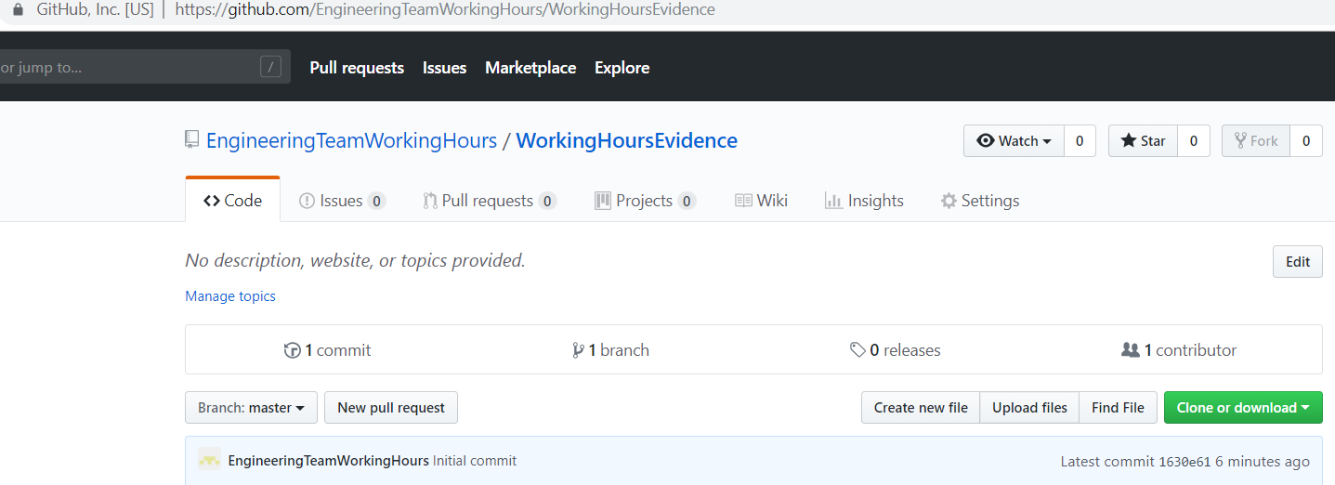

Extract files.

In Eclipse IDE go to File – Import – Existing Maven Projects – Next – Browse – Finish.

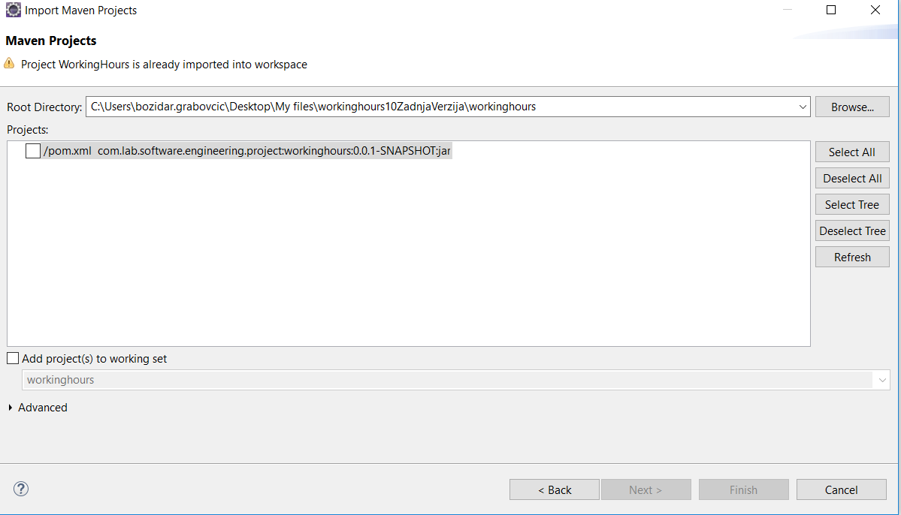

Run as Java Application or Spring Boot App.

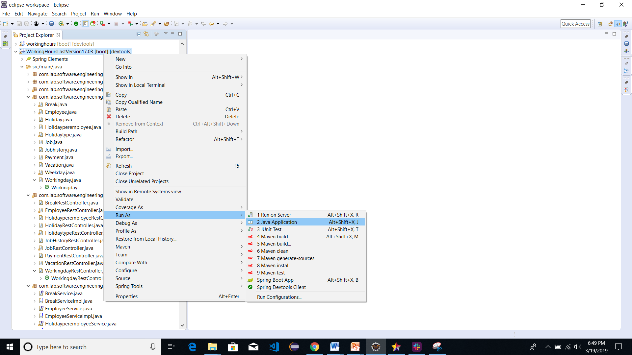

## Frontend

Clone or download project from git



Extract files.

Open Visual Studio Code. Go to File – Open Folder

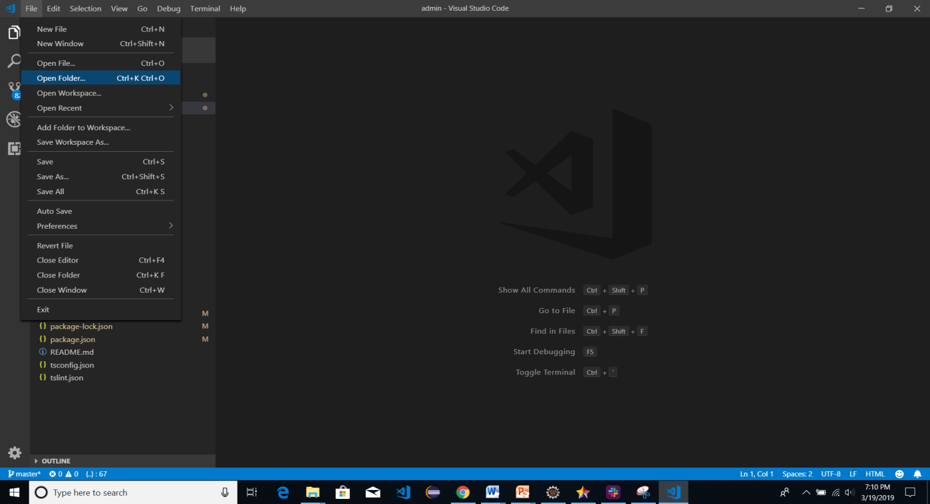

Chose folder.

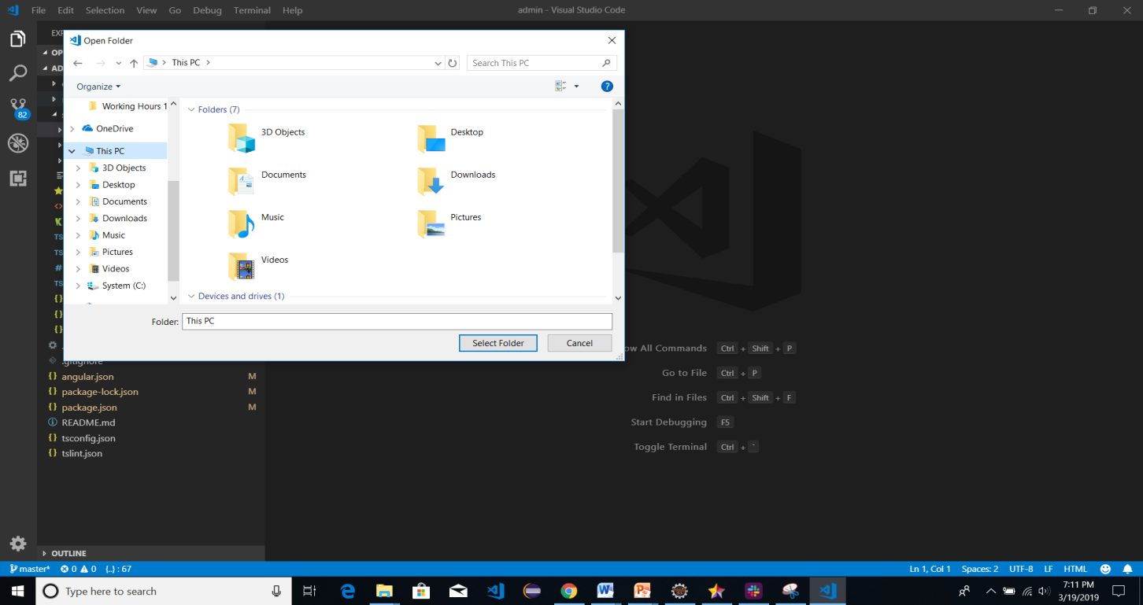

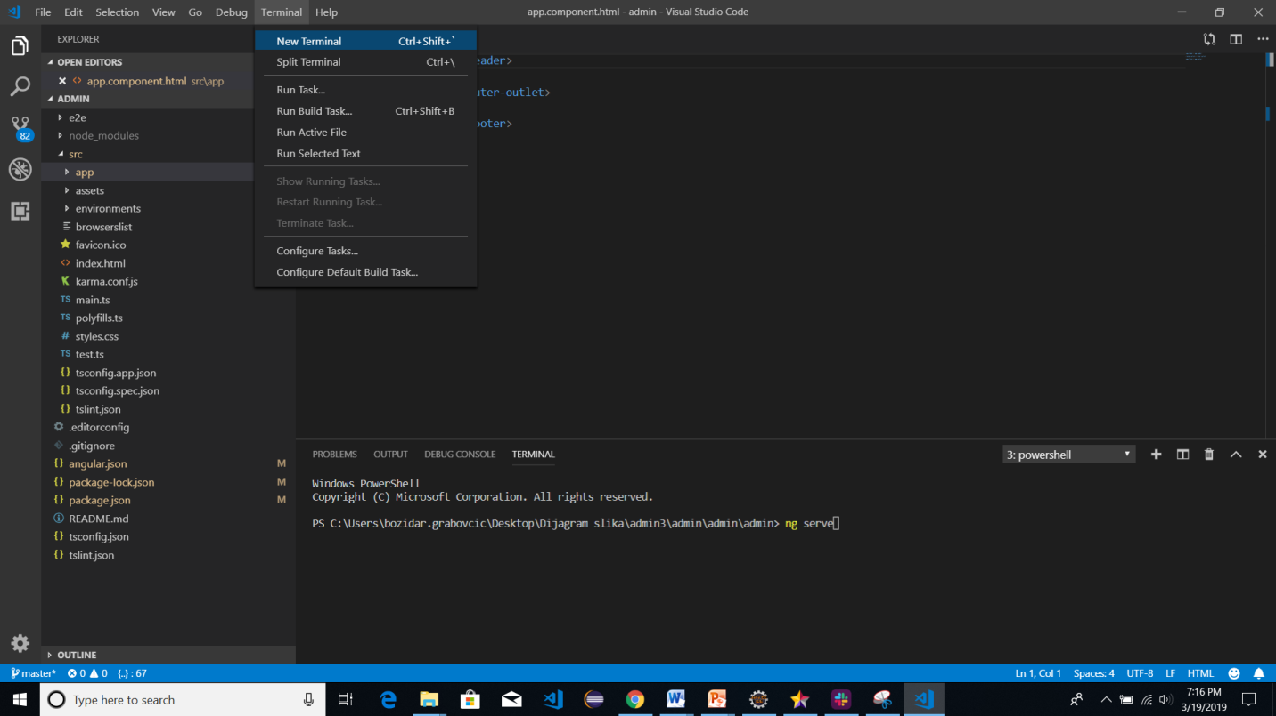

Run command in terminal: ng serve. Angular project will start on localhost:4200, open it in browser. Enjoy in Working Hours Evidence application.